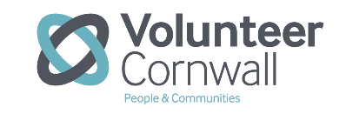
Stroke Befriender Request Form
Referral Date:
Referrer name:  Organisation:  Job role: | Tel:  Email:
Date of Stroke: | Date of Discharge:
Tick box ONLY if client has understood the service being offered and has agreed to their contact details being given to Volunteer Cornwall

Clients Name: | D.o.B:
Address: | Phone:  Mobile:  Email:  Preferred method of contact?
Reason for request:

Summary of impact of stroke Please include details of any difficulties/mobility issues

Aphasia/Communication difficulty and needs Please include level and nature of difficulty

Communication Tools used:
Does the client have a good network of close family or friends visiting or living with them? Please give details

Please provide details of any other disabilities:
Please send this form to:
stroke@volunteercornwall.org.uk
Volunteer Cornwall, Acorn House, Heron Way Truro TR1 2XN
or ring 01872 266997
Volunteer Cornwall registered charity Number 1069957

